Linux Commands(Ubuntu)
1. Cd command: It allows you to easily change the current working directory on your terminal.
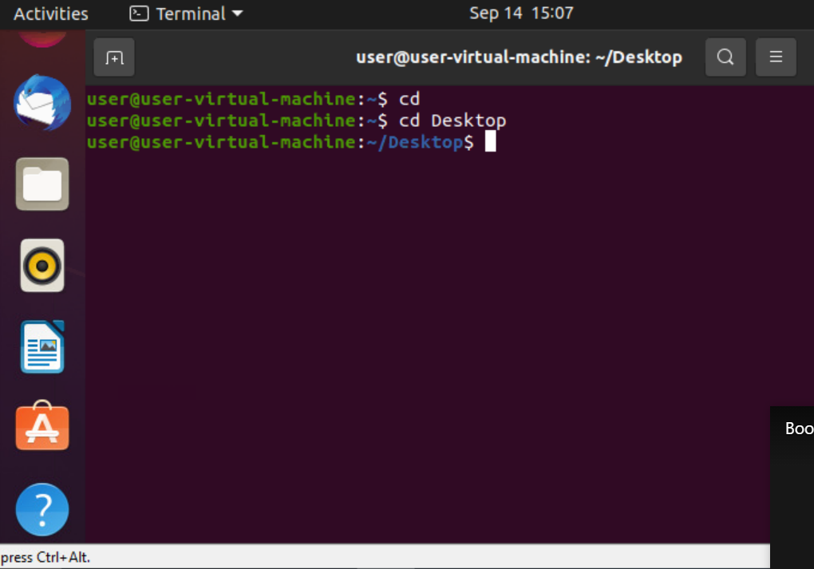

2. Cd demo : changing from desktop to demo directory
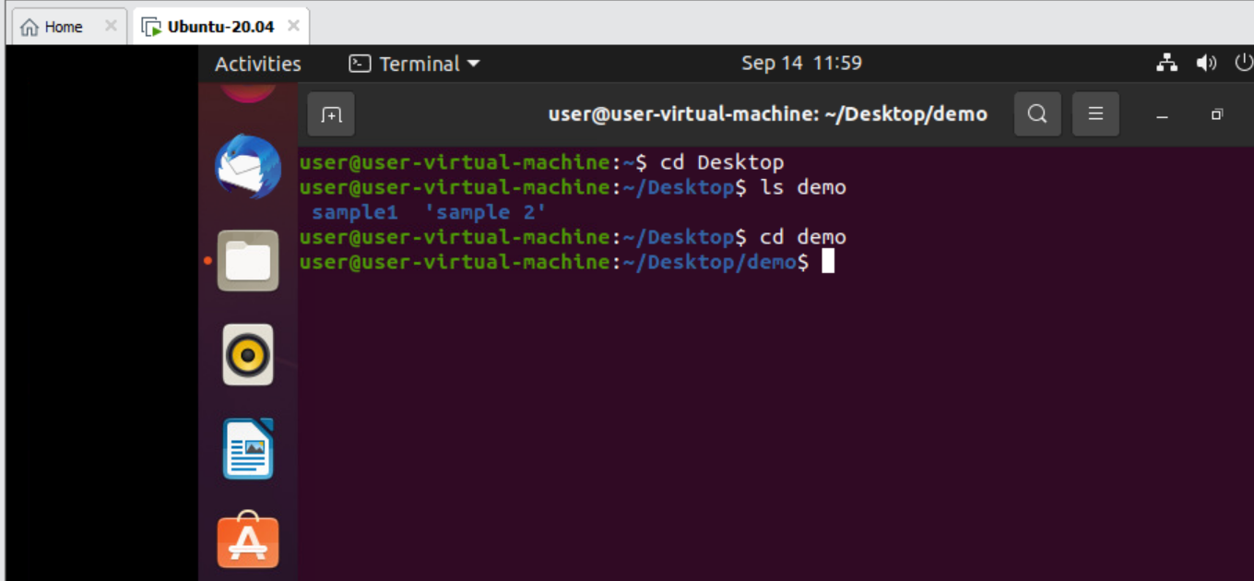
3. cd .. : This command is used to move to the previous directory
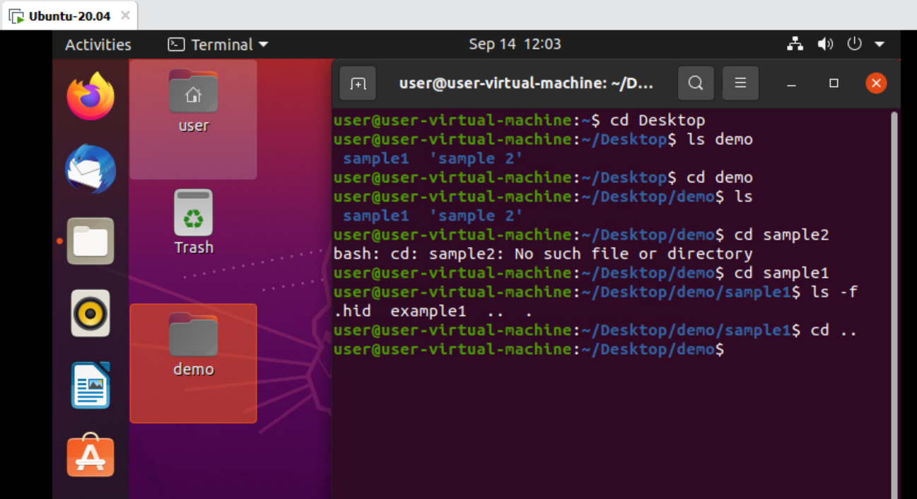
4. cd / : This command will change to the root directory
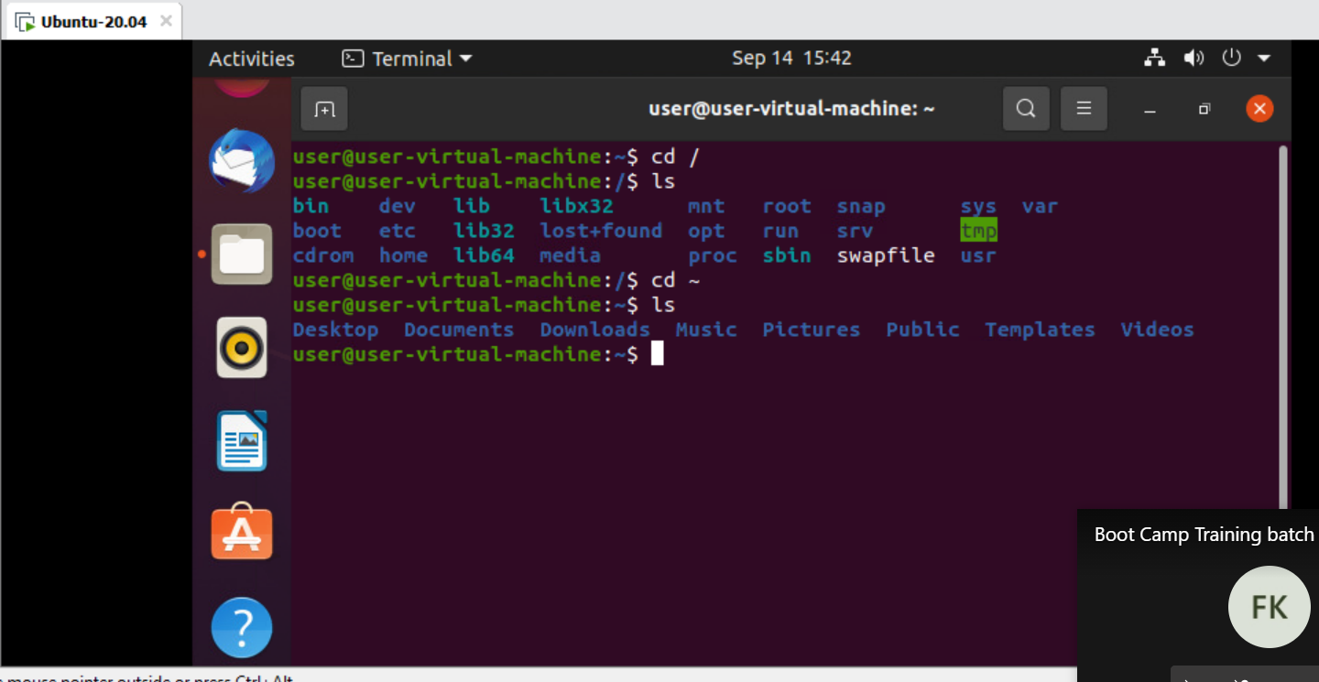
5. clear: This command is used to clear the terminal
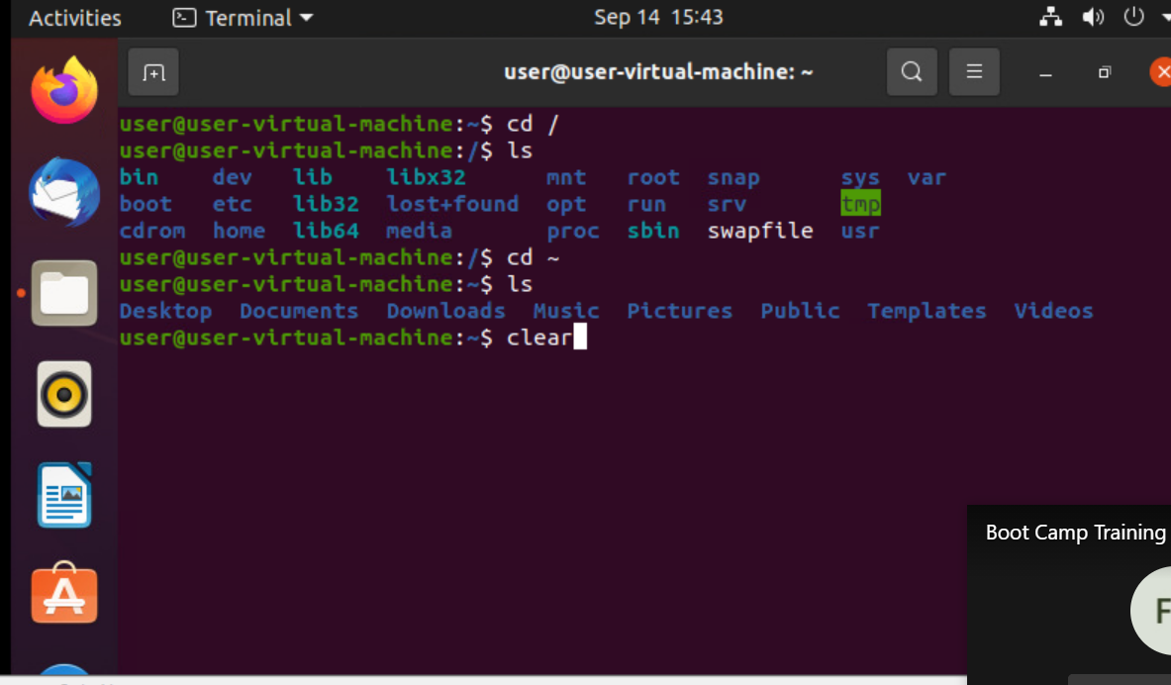

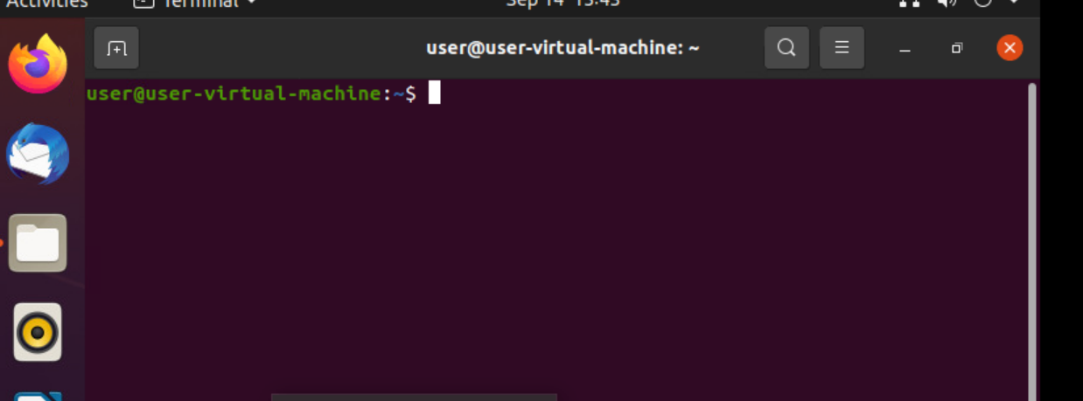
6. Ls : This command is used to get a list of files and directories.

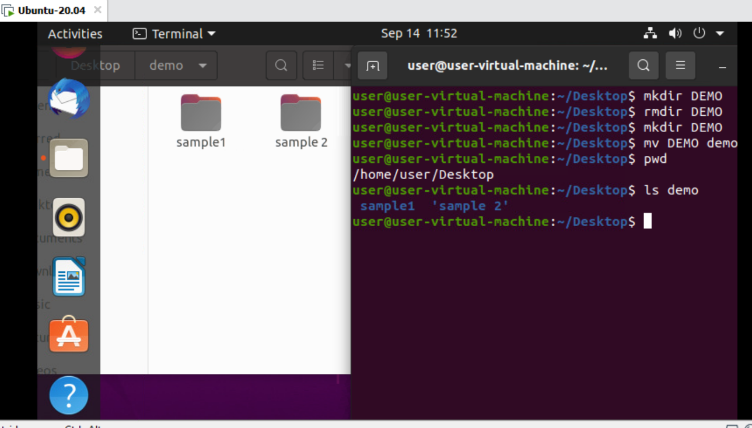
7. Date: This command displays today's date

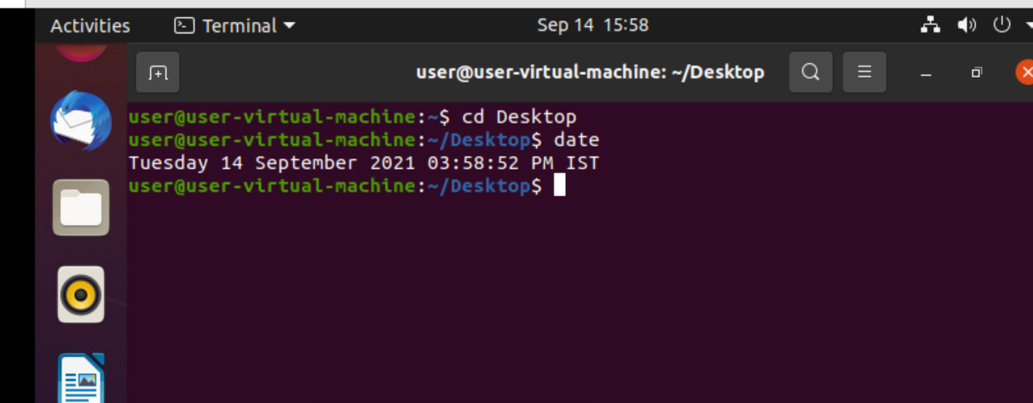
8. Cal : This command displays the calender of the current month

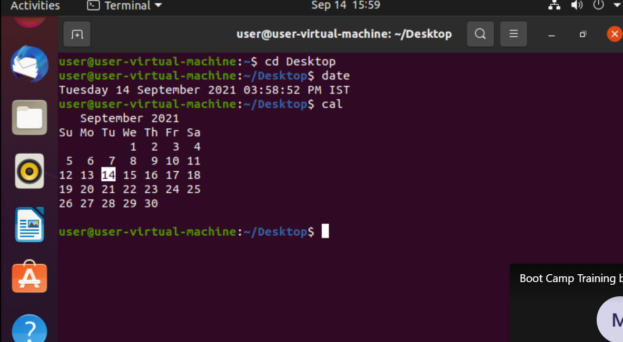

9. echo: This command is used to print the output to the user
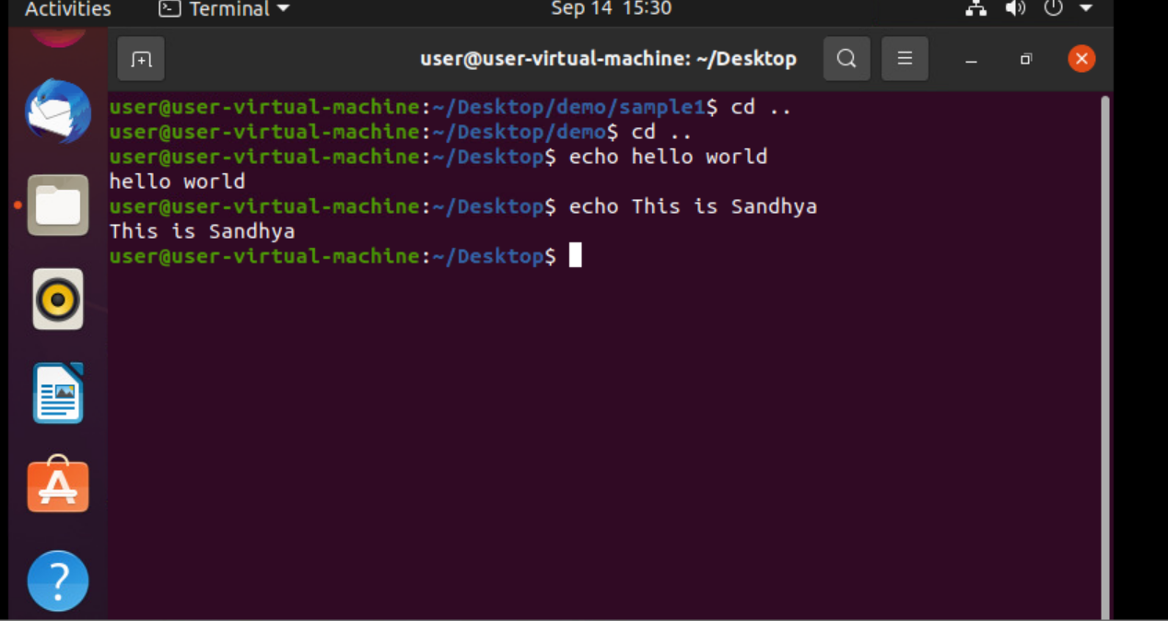
10 . Cat: It reads data from the file and gives their content as output. It helps us to create, view, concatenate files.
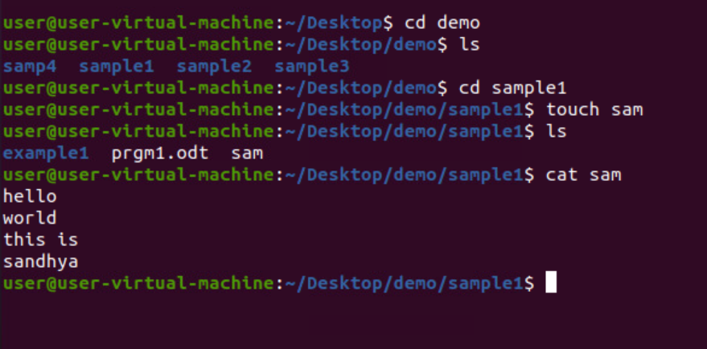
11. tac: It reads data from the file in reverse order
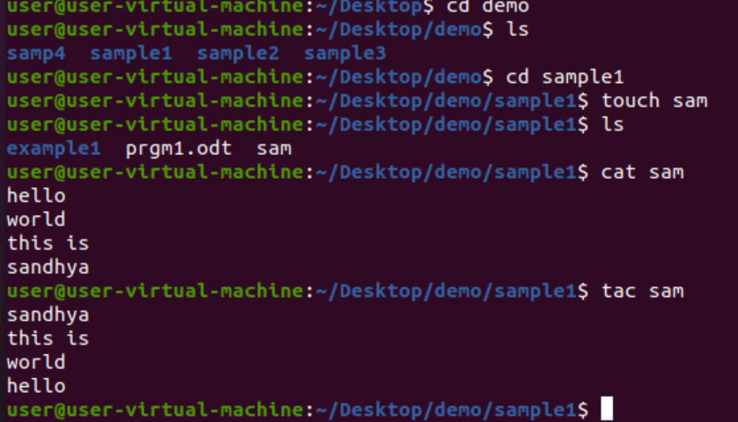
12. Sort: This command sorts the data in ascending and displays the output to the user
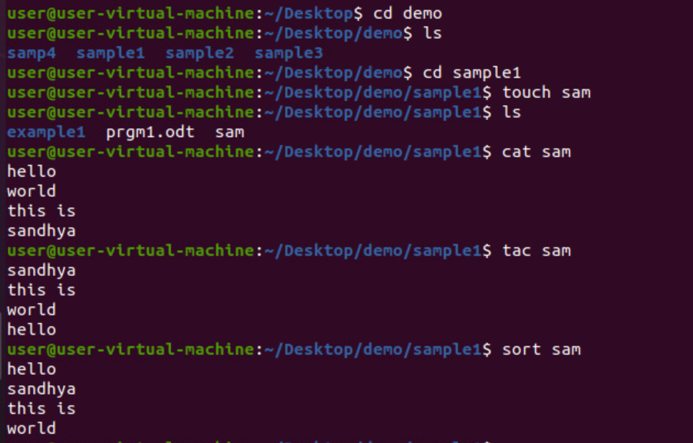
13. Man ls: It gives the information and instruction of any command
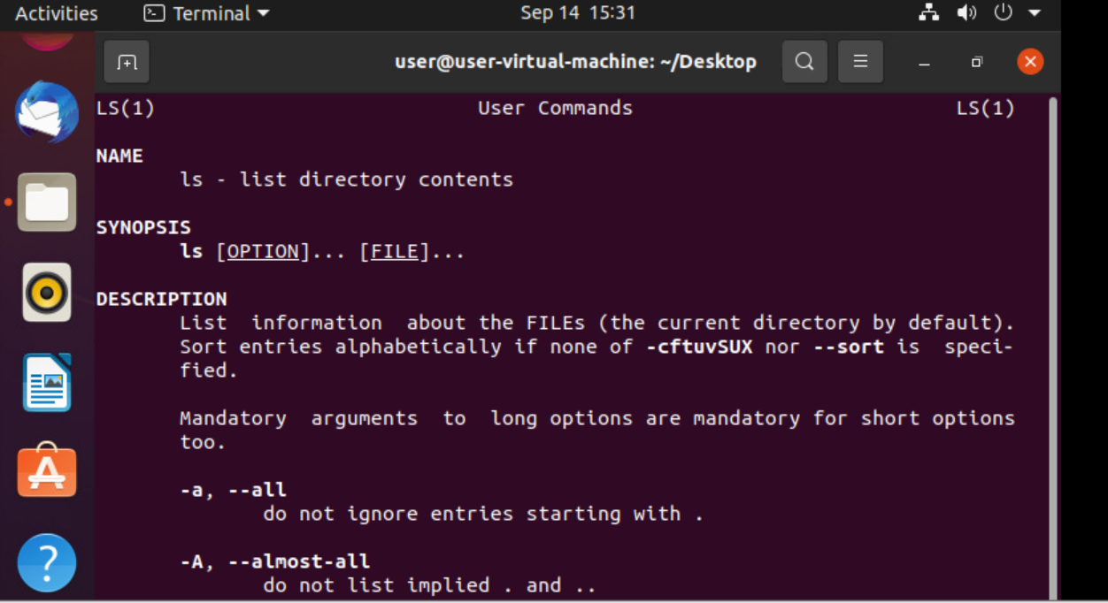
14. pwd: (print working directory) writes the full pathname of the current working directory to the standard output.

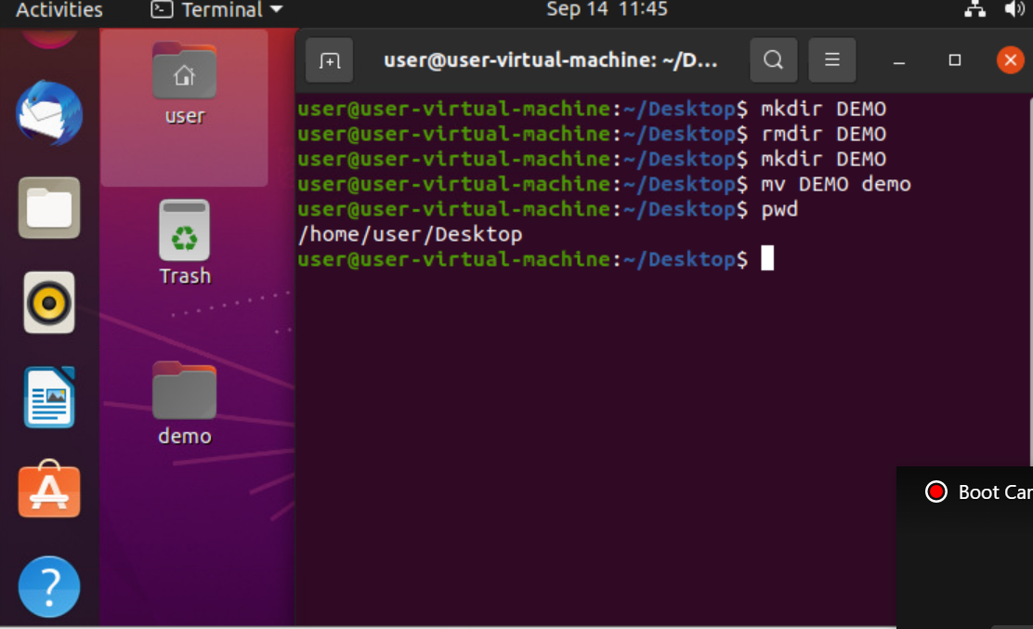
15. mkdir: make directory command is used to make new directory

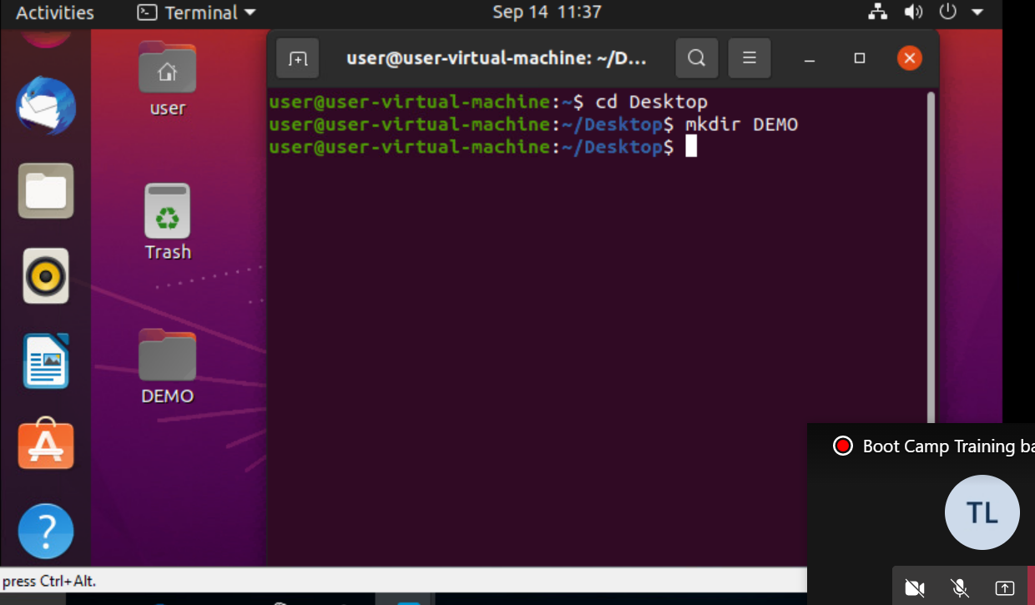
16. The below picture depicts the mkdir command used to create folder inside a folder
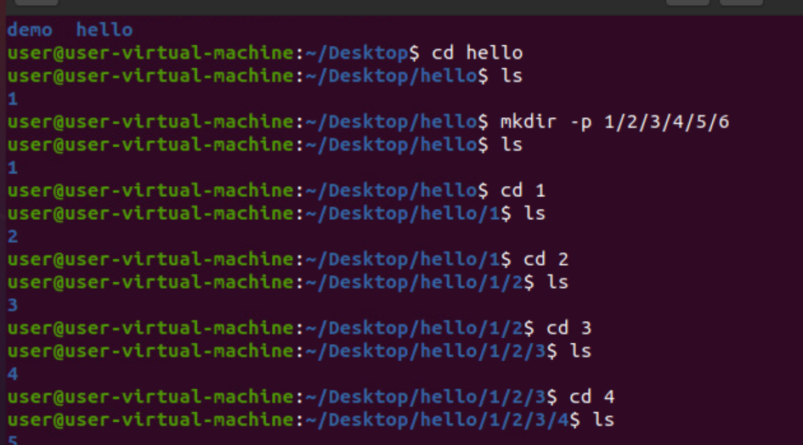
17. The below picture depicts the command mkdir to create folders of the selected folders

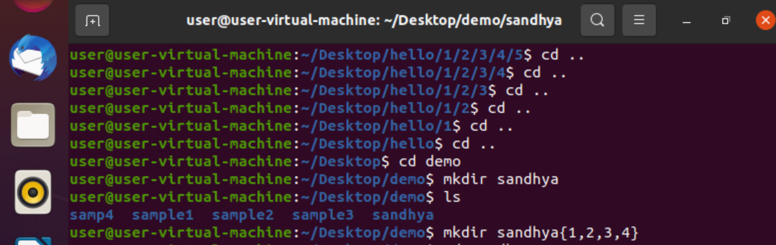
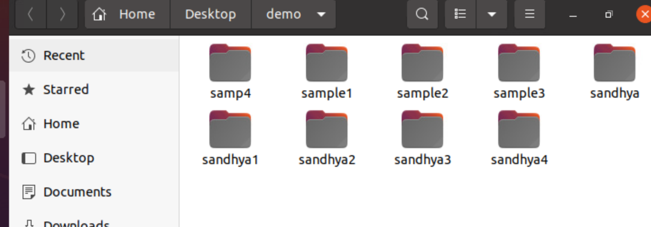
18. mv : moves one or more files or directories from one place to another.

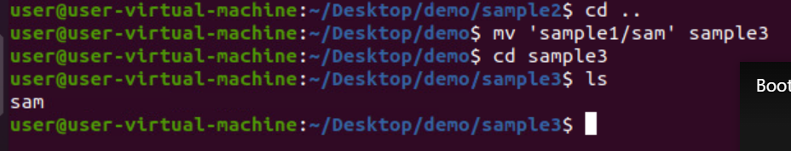
19. mv: this command is also used to rename the file

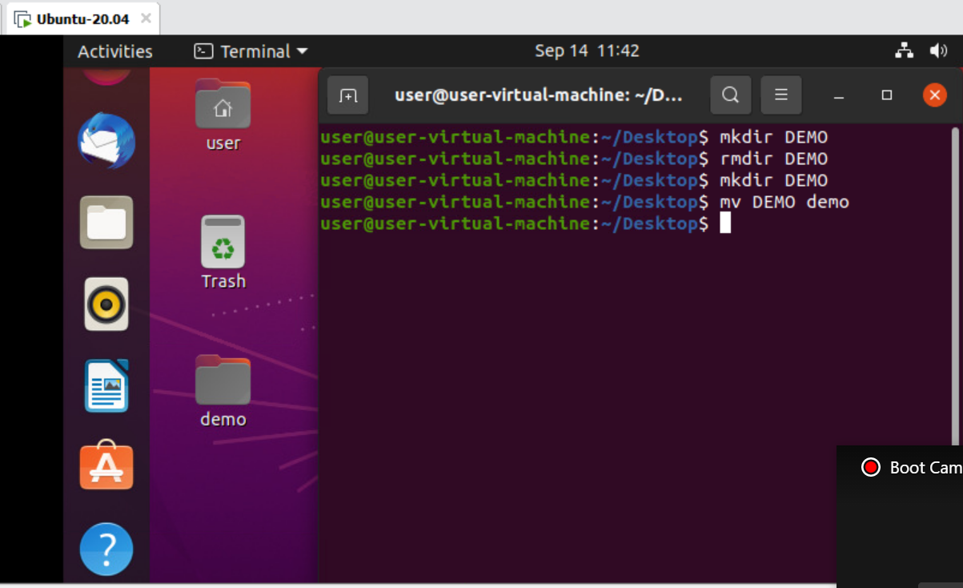
20. cp : The cp command has a simple purpose to copy files and folders from one place to another.
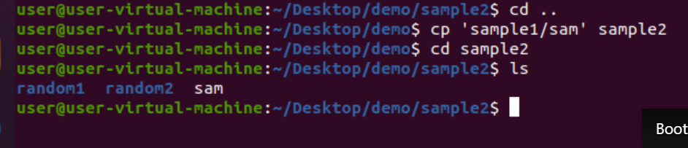
21. rmdir : command which will remove an empty directory on various operating systems.
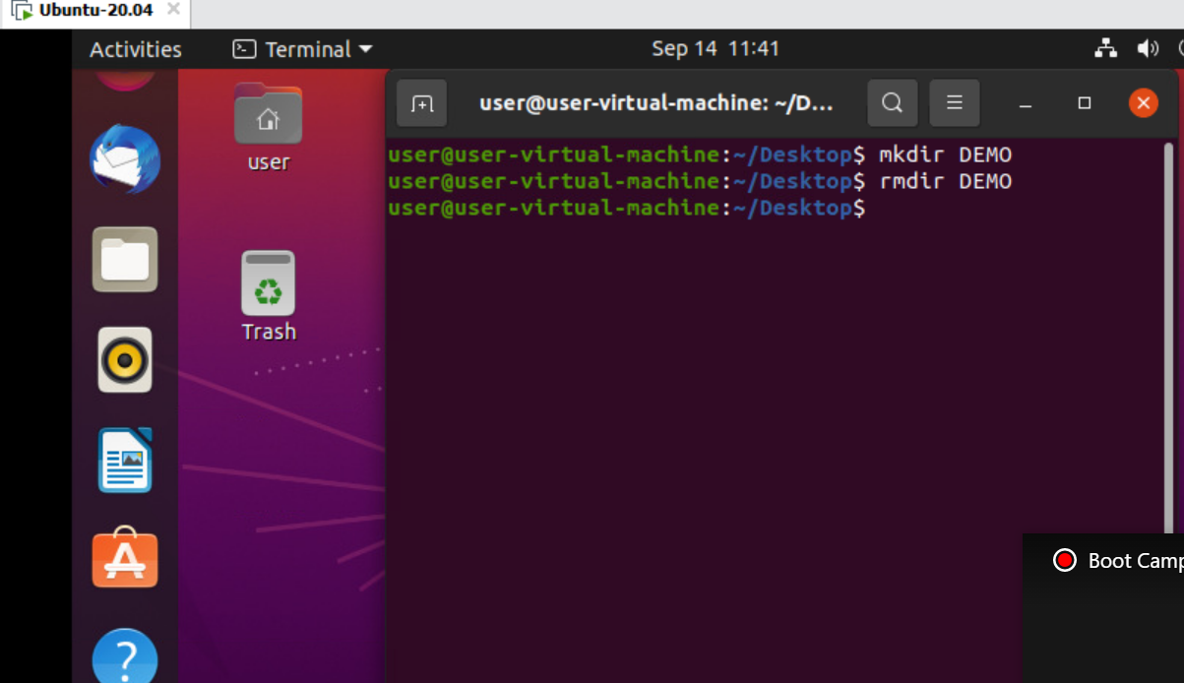
22. rm : we can also remove special files such as, pipes, sockets and device nodes with the rm command
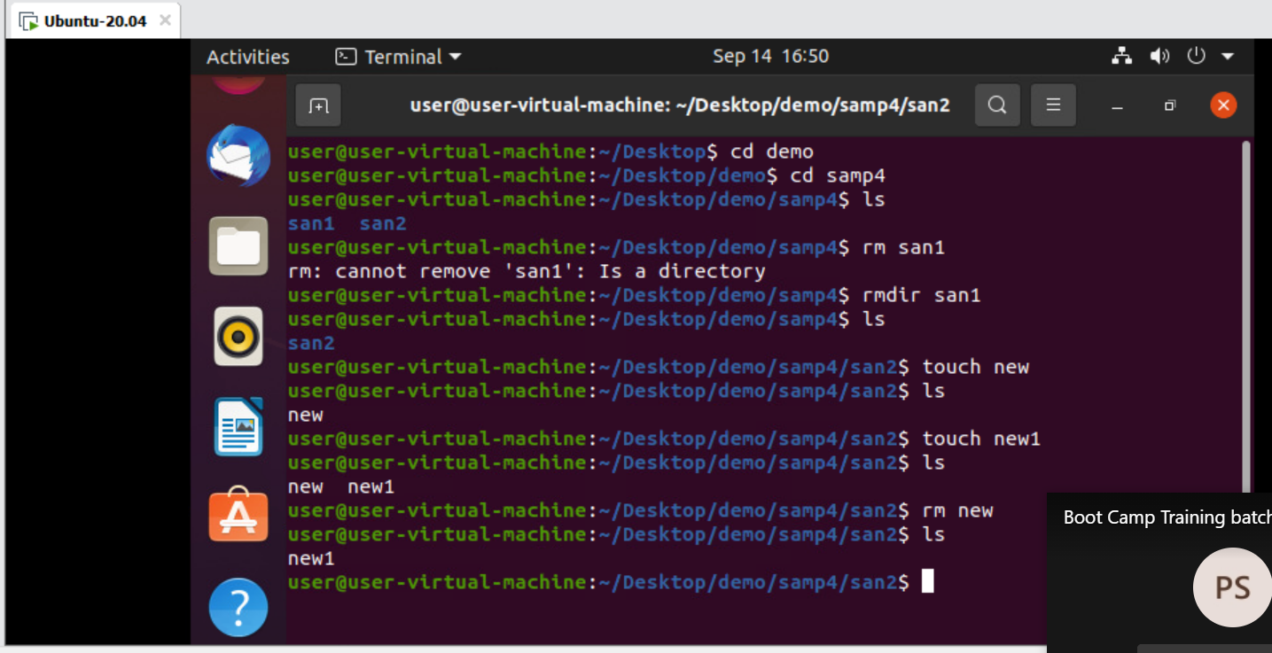
23. rm -rf: This command removes the entire directory, even the files inside the directory will also be removed

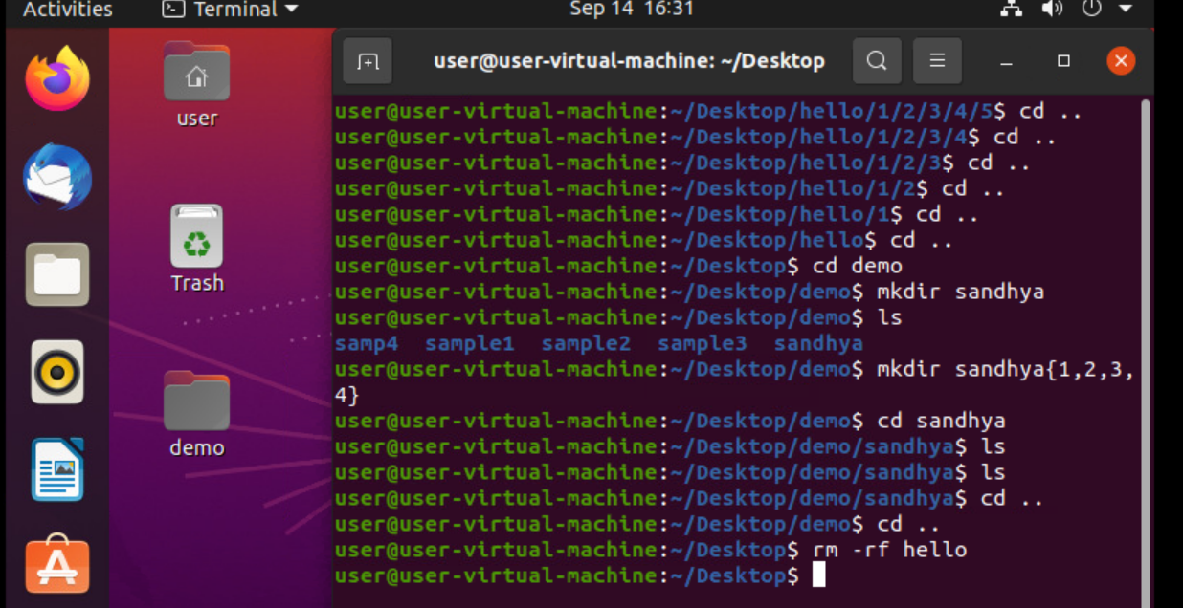
24. ls -f: It shows all folders including hidden folders
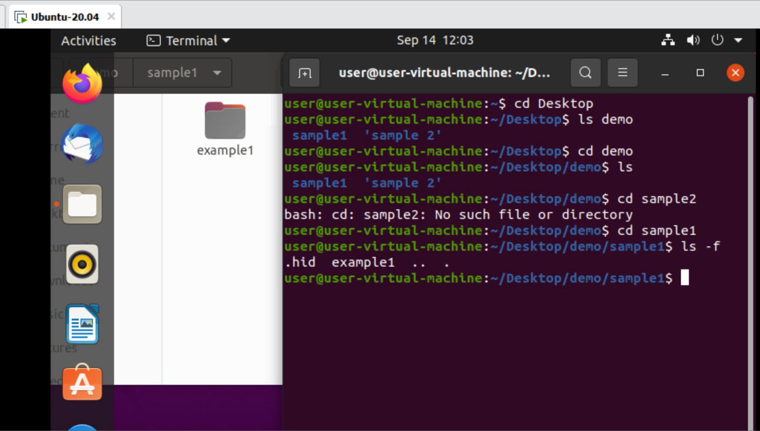
25. ls -a: It shows all the folders including hidden
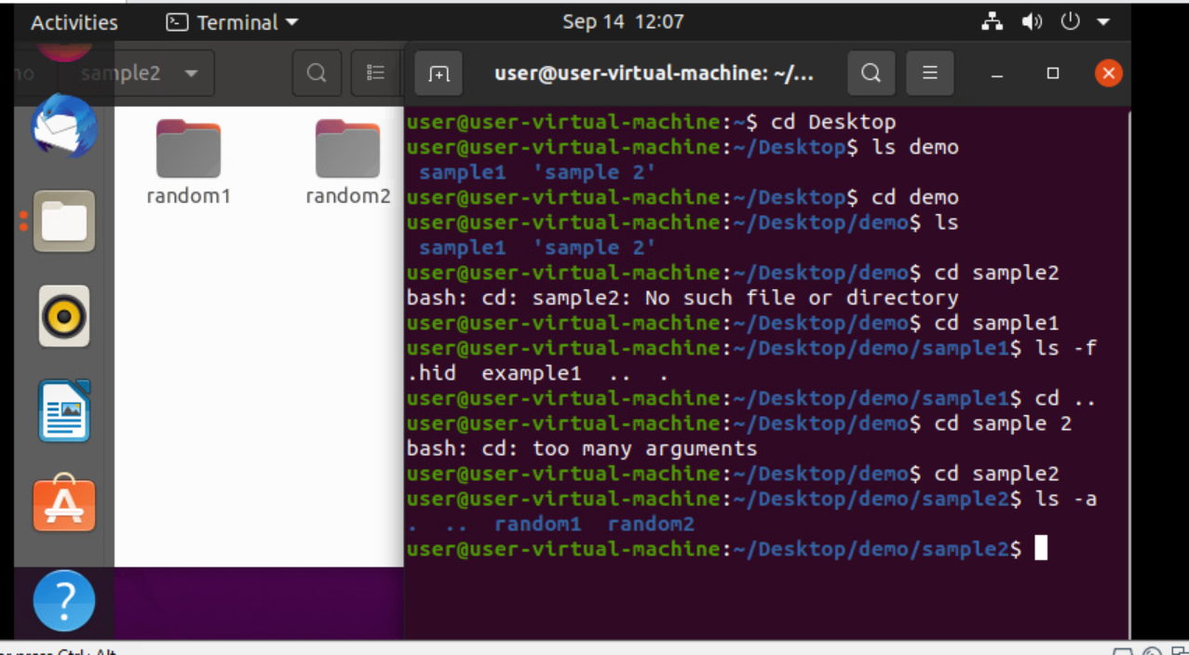
26 ls-A
This command ignores . And .. and displays in dictionary order
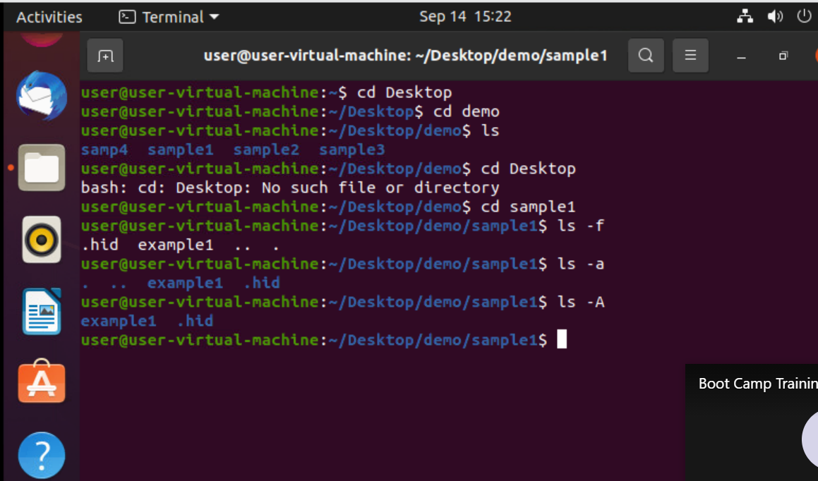
27 ls -l
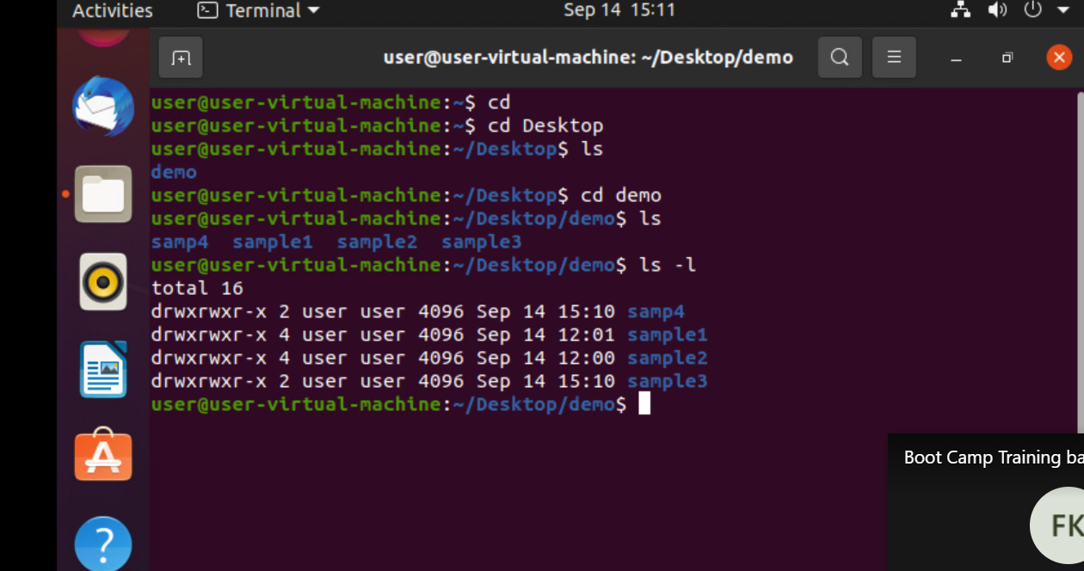
28 ls -l(root)
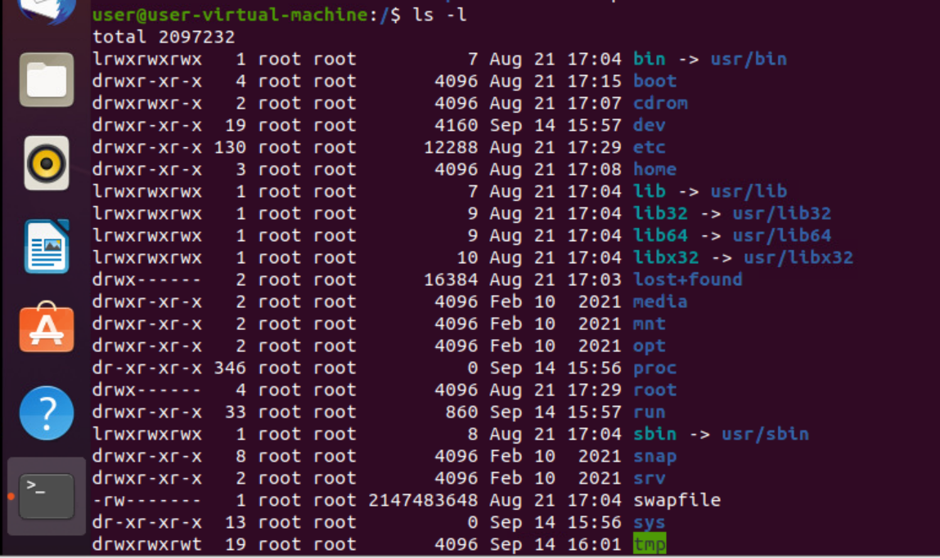
29 ls -l -a
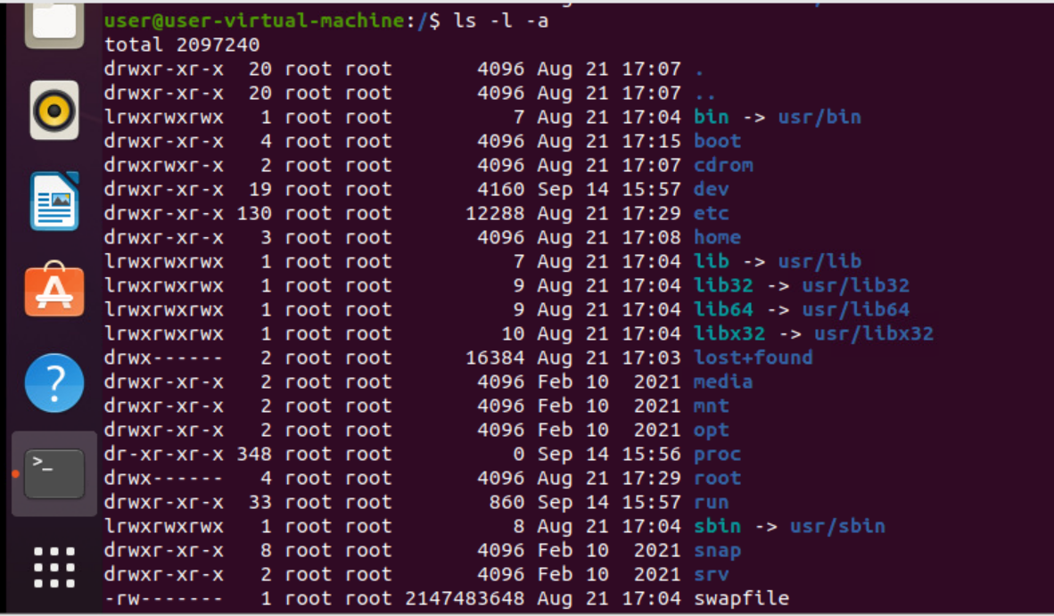
30. ls -l -a -r
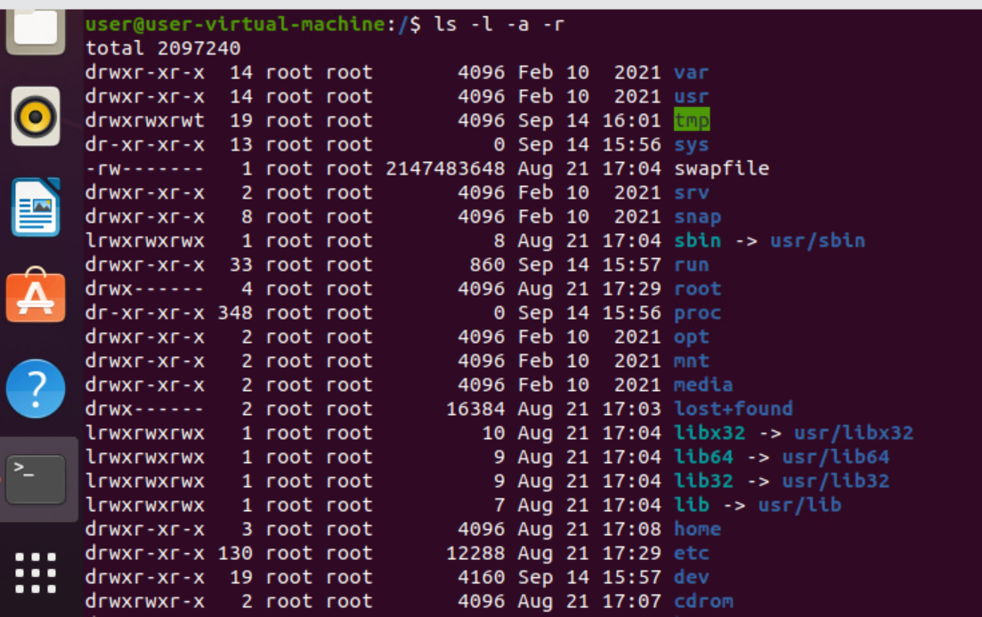
31. ls -lr
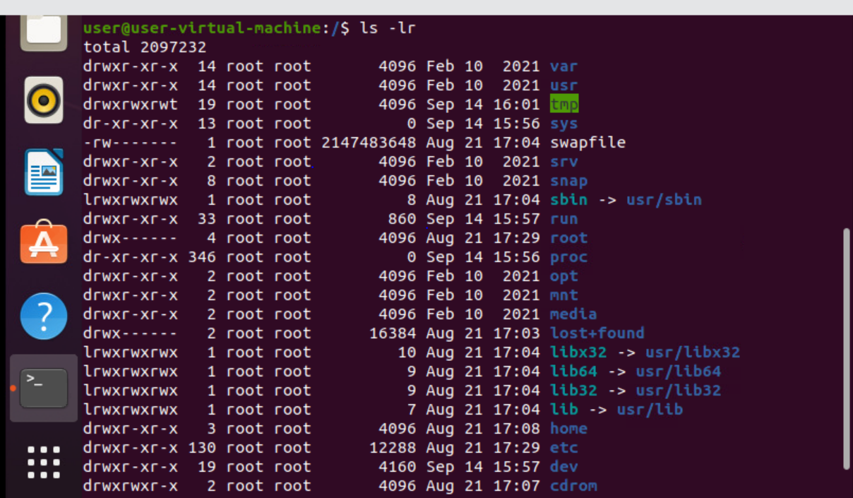
32. ls -lar
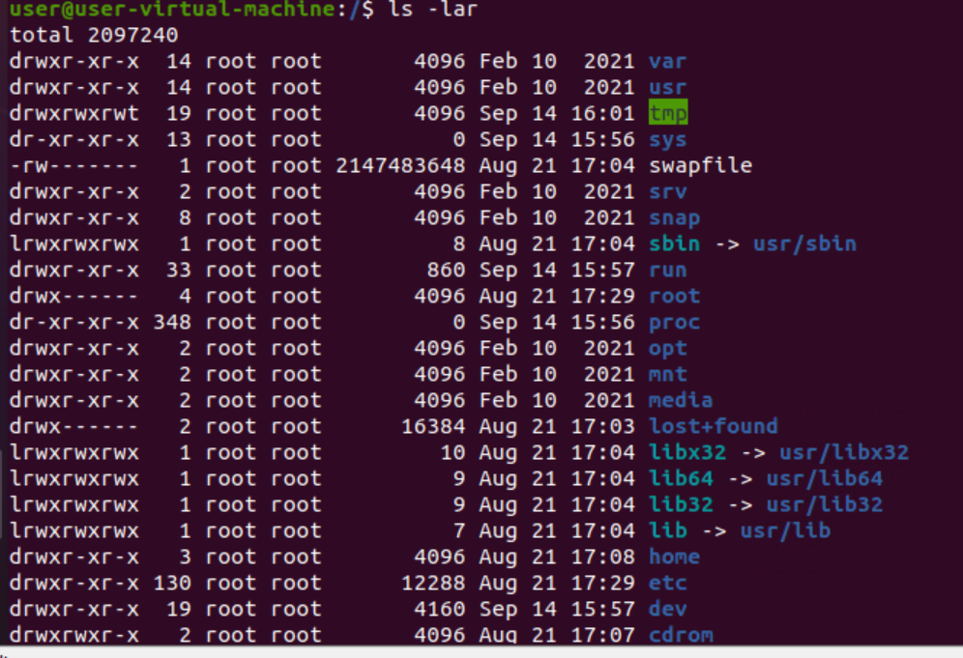
33. touch: used to create new text file

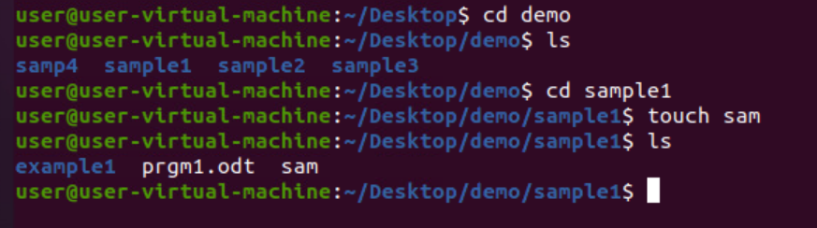
34. Passwd: used to change the current password
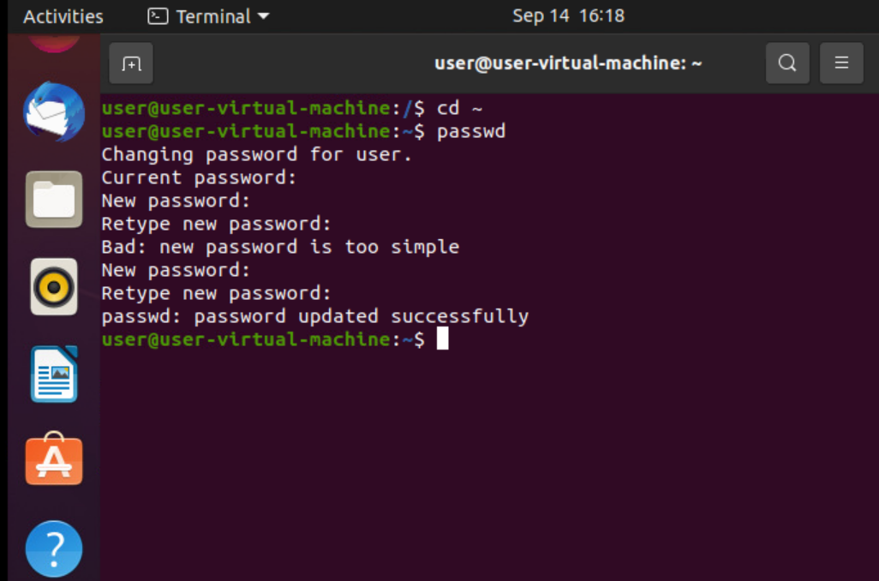
35. Sudo: sudo is a program for Unix-like computer operating systems that allows users to run programs with the security privileges of another user, by default the superuser.
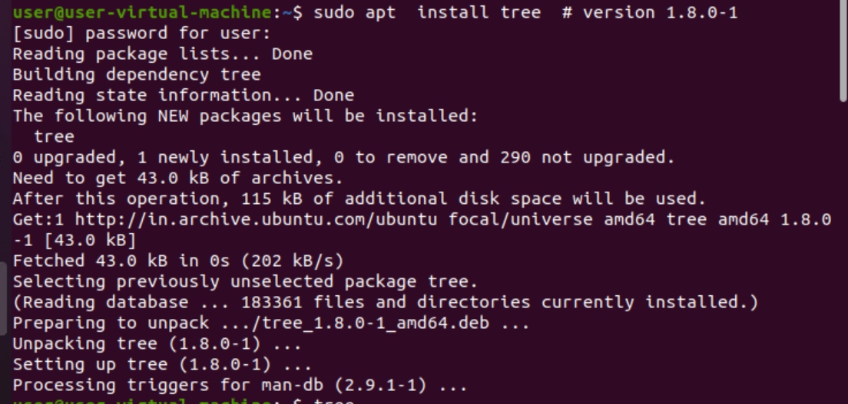
36. Tree : tree is a recursive directory listing command or program that produces a depth-indented listing of files.


